

Para converter um número decimal para qualquer outra base, basta dividir, sucessivamente, o número decimal a ser convertido, pela base para a qual se quer converter, guardando o resto da divisão. O resultado dessa operação é novamente dividido pela base e guarda-se o resto. Este processo irá se repetir até que o resultado seja menor que a base. O resto das divisões ao contrário serão o número convertido.

| **Binário** | | |
| --- | --- | --- |
|  | **Resultado** | **Resto** |
| **22/2** | **11** | **0** |
| **11/2** | **5** | **1** |
| **5/2** | **2** | **1** |
| **2/2** | **1** | **0** |
| **1/2** | **0** | **1** |
| **22₁₀=10110₂** | | |

| **Octal** | | |
| --- | --- | --- |
|  | **Resultado** | **Resto** |
| **22/8** | **2** | **6** |
| **2/8** | **0** | **2** |
| **22₁₀=26₂** | | |

| **Hexadecimal** | | |
| --- | --- | --- |
|  | **Resultado** | **Resto** |
| **22/16** | **1** | **6** |
| **1/16** | **0** | **1** |
| **22₁₀=16₁₆** | | |



| **Binário** | **Sinal Magnitude** | **Complemento de 1** | **Complemento de 2** | **Excesso** |
| --- | --- | --- | --- | --- |
| **-** | **1100 1011** | **1011 0100** | **1011 0101** | **0011 0101** |



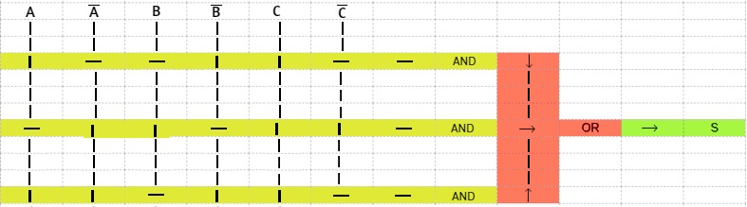

|  | | | |
| --- | --- | --- | --- |
| **a** | **b** | **c** | **S** |
| **0** | **0** | **0** | **0** |
| **0** | **0** | **1** | **0** |
| **0** | **1** | **0** | **1** |
| **0** | **1** | **1** | **0** |
| **1** | **0** | **0** | **1** |
| **1** | **0** | **1** | **1** |
| **1** | **1** | **0** | **1** |
| **1** | **1** | **1** | **0** |

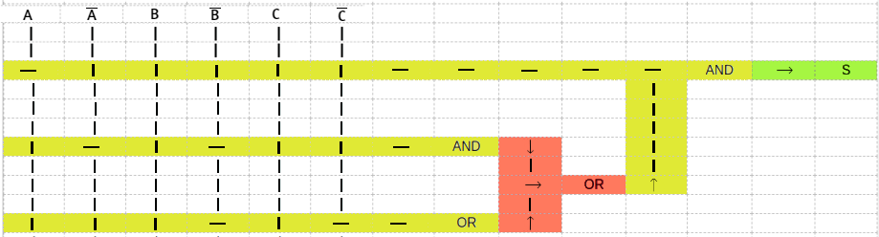

|  | | | |
| --- | --- | --- | --- |
| **a** | **b** | **c** | **S** |
| **0** | **0** | **0** | **0** |
| **0** | **0** | **1** | **0** |
| **0** | **1** | **0** | **0** |
| **0** | **1** | **1** | **0** |
| **1** | **0** | **0** | **1** |
| **1** | **0** | **1** | **1** |
| **1** | **1** | **0** | **1** |
| **1** | **1** | **1** | **0** |

‘



| **a** | **b** | **c** | **s** |  | C\AB | 00 | 01 | 10 | 11 |
| --- | --- | --- | --- | --- | --- | --- | --- | --- | --- |
| **0** | **0** | **0** | **1** |  | 0 | 1 | 1 | 0 | 1 |
| **0** | **0** | **1** | **1** |  | 1 | 1 | 0 | 0 | 1 |
| **0** | **1** | **0** | **1** |  |  |  |  |  |  |
| **0** | **1** | **1** | **0** |  |  |  |  |  |  |
| **1** | **0** | **0** | **0** |  | **(A'.(C'+B'))+(A.B)** | | | | |
| **1** | **0** | **1** | **0** |  |  |  |  |  |  |
| **1** | **1** | **0** | **1** |  |  |  |  |  |  |
| **1** | **1** | **1** | **1** |  |  |  |  |  |  |
|  |  |  |  |  |  |  |  |  |  |
| **a** | **b** | **c** | **s** |  | C\AB | 00 | 01 | 10 | 11 |
| **0** | **0** | **0** | **0** |  | 0 | 0 | 0 | 1 | 0 |
| **0** | **0** | **1** | **0** |  | 1 | 0 | 1 | 1 | 1 |
| **0** | **1** | **0** | **0** |  |  |  |  |  |  |
| **0** | **1** | **1** | **1** |  |  |  |  |  |  |
| **1** | **0** | **0** | **1** |  | **(A.(C+B))+(C.A'.B)** | | | | |
| **1** | **0** | **1** | **1** |  |  |  |  |  |  |
| **1** | **1** | **0** | **0** |  |  |  |  |  |  |
| **1** | **1** | **1** | **1** |  |  |  |  |  |  |
|  |  |  |  |  |  |  |  |  |  |
| **a** | **b** | **c** | **s** |  | C\AB | 00 | 01 | 10 | 11 |
| **0** | **0** | **0** | **1** |  | 0 | 1 | 1 | 0 | 0 |
| **0** | **0** | **1** | **1** |  | 1 | 1 | 1 | 1 | 1 |
| **0** | **1** | **0** | **1** |  |  |  |  |  |  |
| **0** | **1** | **1** | **1** |  |  |  |  |  |  |
| **1** | **0** | **0** | **0** |  | **C+(C'.A')** | | | | |
| **1** | **0** | **1** | **1** |  |  |  |  |  |  |
| **1** | **1** | **0** | **0** |  |  |  |  |  |  |
| **1** | **1** | **1** | **1** |  |  |  |  |  |  |